# QA Assignment

If you are not familiar with any section, please leave a comment and you can try to describe how you think it could be done in sentences if you have an idea. If you are not sure at all, you can skip it and we can discuss it during the evaluation interview.

## 1. Strategy part

#### Assignment

● Describe how you would implement automated testing for a web application with the goal to eliminate functional and data related bugs and errors.

Answer:

For this purpose, I have done these steps:  
1. Researching the platform and functions. Writing Test cases on the required testing area  
2. Identifying the Test cases that need to be automated  
3. Choosing appropriate tools for automation  
4. Developing test scripts  
5. Executing test scripts  
6. Analysing the test results and writing the corresponding Defect report

● What set of software tools do you want to use and why?

Answer:

I used Selenium, PyCharm for Python, Pytest as a framework and additionally Selectors Hub.

Selenium provides a comprehensive set of functions and APIs that allow to control web browsers and interact with web pages, making it an ideal tool for testing web applications.  
PyCharm is a powerful integrated development environment (IDE) for Python that can help to write, edit, and debug Python code.  
Pytest is a flexible and powerful testing framework that can be used for different types of testing.  
Selectors Hub is a browser extension that can help to generate complex selectors for web elements quickly and efficiently.

## 2. Test case

#### Assignment

● Log into the demo version of #NDA (if you do not have an access, please contact #NDA)

● Go to page #NDA

● We want to test filtering on top side of the page:

○ Time granularity selector

○ Attribution model selector

○ Date picker selector



● To home some difference between models we need to select e.g. one platform – you can find it on the right side and select Google Ads.

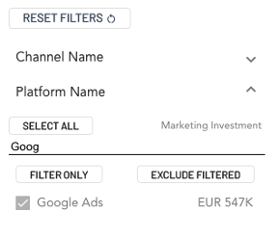

● Create an example TEST CASE for testing the correct behavior of all 3 filters affecting the main graph.

#### Conditions

● All 3 dimensions affecting data displayed in main graph if one platform name is selected – e.g. Google Ads

● Data in the chart is obtained by API request and let’s assume data is correct (doesn’t need to be covered by this test)

● Demo data is available only for period from 1.1.2020 to 31.12.2020

● For this test you can ignore any other filtering than mentioned.

● Measurements in the graph are default: Marketing Investment and Margin Return on Marketing Investment.

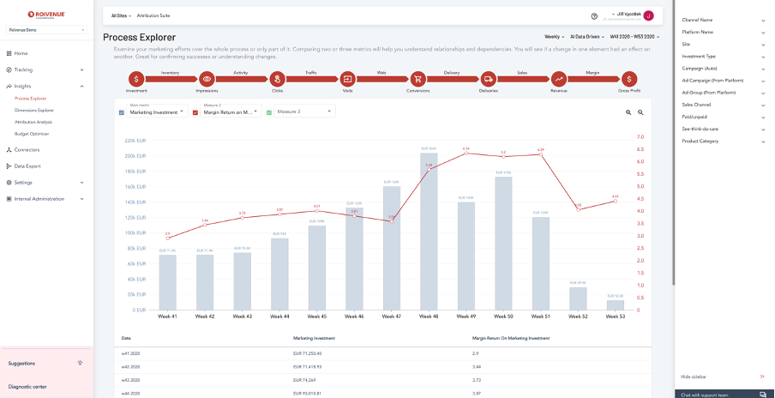

## 3. Automated test

#### Assignment

● Create an automated test for the TEST CASE you prepared.

## 4. Report

#### Assignment

● Create DEFECT REPORT from the automated test as a result of the test.